**SyncRX Enrollment Pharmacy Check List**

**Patient Name:______________________ DOB_______**

**Please use this checklist to complete all pages to**

**allow for a smooth transition in the compliance program**

* Patient agrees to use Bremo Pharmacy and signed the agreement to enroll in SyncRX/Dispill p1.
* New Patient Information Form complete p 2 (Include all of the following: contact information, payment method, known drug allergies, prescription insurance (copies) and medical conditions
* Current Pharmacy Information provided. p3
* Current Medication List completed or provided p3.
* Counts of all medications to be synchronize are provided or a home visit requested p3.
* List of current PCP & specialist providers if available p3.
* Patient request Dispill 28 day packaging p4

OR

* Patient requests Bubble packing 30 days individually per drug

OR

* Bottles
* MAR; HOA= ____________________________________________
* Other special needs: ______________________________________

Home Health/Family Contact Name: _________________________

Phone: _______________________________________________

**Patient Copy**

**Agreement to Participate in the   
Synchronized Prescription Refill Service**

**I understand the program advantages and the following conditions of participation to achieve the maximum benefits from the service. *I hereby agree:***

* To accept a phone call each month from Bremo pharmacy to discuss my chronic prescription refills.
* To pick up medications or accept a delivery on my assigned refill date.
* If necessary, to pay an extra co­pay *one time* for each medication in order to make all refills due on the same day.
* To keep an open dialogue with my pharmacist regarding **doctor’s appointments, hospital/urgent care visits, and changes in my health status.**
* An option, to a 28-day cycle fill to package my medications in Dispill to keep my medications due on the same day

**I have read this document, understand it, and have had all questions answered satisfactorily.**

**Thank you for your interest in the SyncRx at Bremo Pharmacy. Advantages**

**of participating in the program include:**

* Increased convenience—a single monthly trip to the pharmacy or delivery
* Peace of mind from being able to get medications on time and in one order
* More personal contact with your pharmacist to ask questions and discuss medications
* Increased understanding of your medication, its purpose, potential side effects and costs.
* Your prescription records can be more easily updated to reflect changes in therapy made by doctors or upon hospital discharge.
* Waived delivery and packaging fees for enrolling in the program

**First Pick Up Appointment Scheduled for: __________________**

**New PatientInformation Form**

**Pharmacy Copy, please read and sign below.**

**Agreement to Participate in the   
Synchronized Prescription Refill Service**

Thank you for your interest in the SyncRx at Bremo Pharmacy. Advantages

of participating in the program include:

* Increased convenience—a single monthly trip to the pharmacy or delivery
* Peace of mind from being able to get medications on time and in one order
* More personal contact with your pharmacist to ask questions and discuss medications
* Increased understanding of your medication, its purpose, potential side effects and costs.
* Your prescription records can be more easily updated to reflect changes in therapy made by doctors or upon hospital discharge.
* Waived delivery fee for enrolling in the program

**I understand the program advantages and the following conditions of participation to achieve the maximum benefits from the service. *I hereby agree:***

* To accept a phone call each month from Bremo pharmacy to discuss my chronic prescription refills.
* To pick up medications or accept a delivery on my assigned refill date.
* If necessary, to pay an extra co­pay *one time* for each medication in order to make all refills due on the same day.
* To keep an open dialogue with my pharmacist regarding **doctor’s appointments, hospital/urgent care visits, and changes in my health status.**
* An option, to a 28-day cycle fill to package my medications in Dispill to keep my medications due on the same day
* To inform the pharmacy of any changes in contact information or address.

**I have read this document, understand it, and have had all questions answered satisfactorily.**

_______________________________________________________________

Patient Name (*Please print*)

________________________________________ _______________________

Patient Signature Date

________________________________________ _______________________

Pharmacist Signature Date

**Please list the medications you are currently taking to be transferred:**

|  |  |  |
| --- | --- | --- |
| **Rx # Medication name and strength**  **Pharmacy Name and phone #**  **Physician and phone #** | **Date of pill count**  **And Quantity Remaining** | **Time of date to take for packs**  **AM, NOON, PM, Bedtime** |
| RX # |  |  |
| RX # |  |  |
| RX # |  |  |
| RX # |  |  |
| RX # |  |  |
| RX # |  |  |
| RX # |  |  |
| RX # |  |  |
| RX # |  |  |
| RX # |  |  |

|  |  |  |  |  |
| --- | --- | --- | --- | --- |
| Name _________________ ___ _________________ | | Date of Birth ____ /____ /____ | | |
| *First MI Last Name* | | *mm dd yy* | | |
| SSN ____________________________ | |  | ❏Male ❏Female | |
| Address __________________________________ __________________ __ ___________ | | | | |
| *Street City State Zip Code* | | | | |
| Phone ______ - ______ - _________ ❏ This is my preferred form of contact | | | | |
| E-Mail ____________________________ ❏ This is my preferred form of contact | | | | |
| Family Contact: _______________________ Relation :_____________________  Phone : _____-_____-_____ ❏ I give my consent to contact regarding my prescriptions/payments | | | | |
| Primary Care Physician _________________________________________________ | | | | |
| * ***** Drug Allergies❏ no ❏ yes, describe reaction: _____________________________ | | | | |
| **Primary Prescription Insurance Information**  Plan Name: _______________________________ RX BIN:____________ RX PCN:_____________  ID #: _____________________________________ RX GROUP: _______________  Pharmacy Help-Desk Phone #: ___________________________ | | | | |
| **Secondary Prescription Insurance Information**  Plan Name: _______________________________ RX BIN:____________ RX PCN:_____________  ID #: _____________________________________ RX GROUP: _______________  Pharmacy Help-Desk Phone #: ___________________________ | | | | |
| **Preferred Method of Payment:** ❏Cash on Delivery ❏ Credit Card ❏ Check | | | | |
| **Please check the following health conditions you have** | | | | |
| ❏ Acid Reflux (GERD)  ❏ Anxiety  ❏ Arthritis  ❏ Asthma  ❏ Bipolar disorder  ❏ Cancer  ❏ Chest pain (Angina)  ❏ COPD  ❏ Congestive heart failure  ❏ Depression  ❏ Diabetes (Type I or II) | ❏ Kidney disease  ❏ Emphysema  ❏ Glaucoma  ❏ Hardening of arteries  ❏ Headaches  ❏ Hypothyroid  ❏ Hyperthyroid  ❏ Irregular heart beat (Arrhythmia)  ❏ HIV / AIDS  ❏ High blood pressure  ❏ High cholesterol | | | ❏ Liver disease  ❏ Parkinson’s disease  ❏ Previous heart attack  ❏ Previous stroke  ❏ Schizophrenia  ❏ Seizures  ❏ Sexual dysfunction  ❏ Skin problems  ❏ Stomach ulcers  ❏ Thyroid Problems  ❏ Other _______________ |
| Do you currently smoke?❏Yes ❏No If yes, how many packs per day? _________ | | | | |
| Do you prefer NON-SAFETY CAPS for your prescription bottles?❏Yes ❏No | | | | |
| **I understand the importance& agree to notify the pharmacy if any of the above information changes ❏Yes ❏No** | | | | |
| **Signat Signature: __________________________________________________Date:** _________________ | | | | |

**DISPILL 28 DAY PACKAKING TO START ON THE SAME DAY OF THE WEEK EVERY 4 WEEKS** – ALL MEDS PACKAGED TOGETHER AS MORNING, NOON, EVENING, AND/OR BEDTIME

**BUBBLE CARD 30 COUNT PACKAKING – 1 CARD FOR MEDICATION EACH 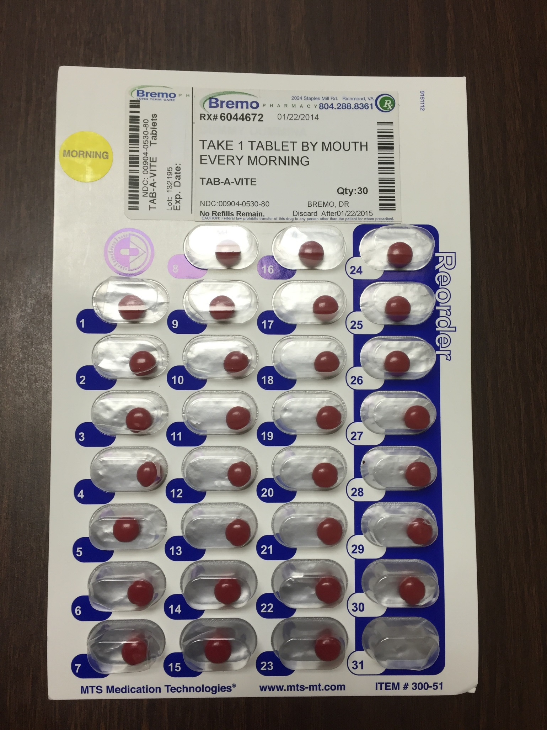DOSING TIME(S)**