SYNC RX

PATIENT ENROLLMENT FORMS

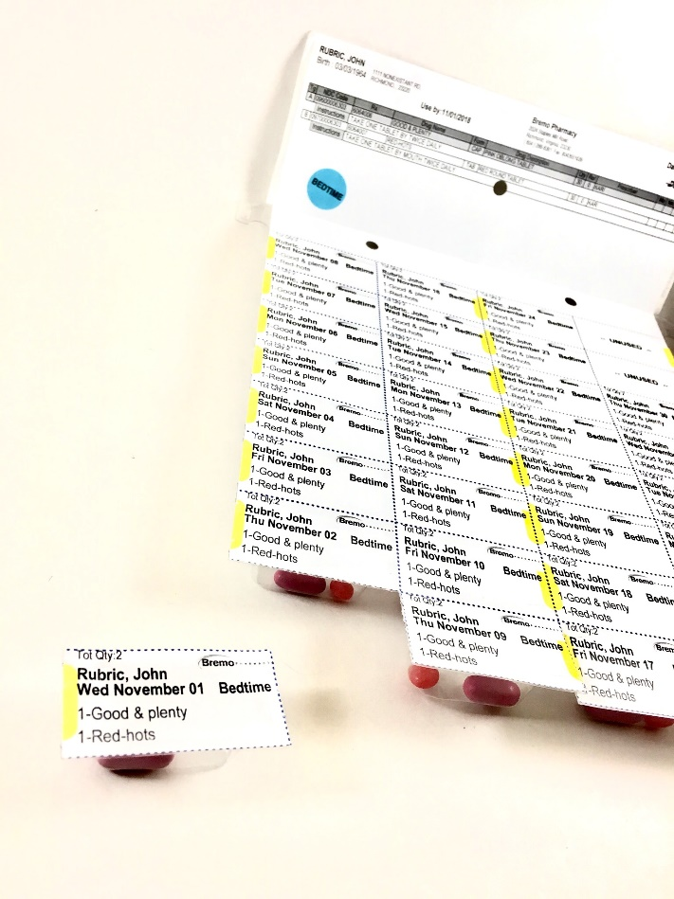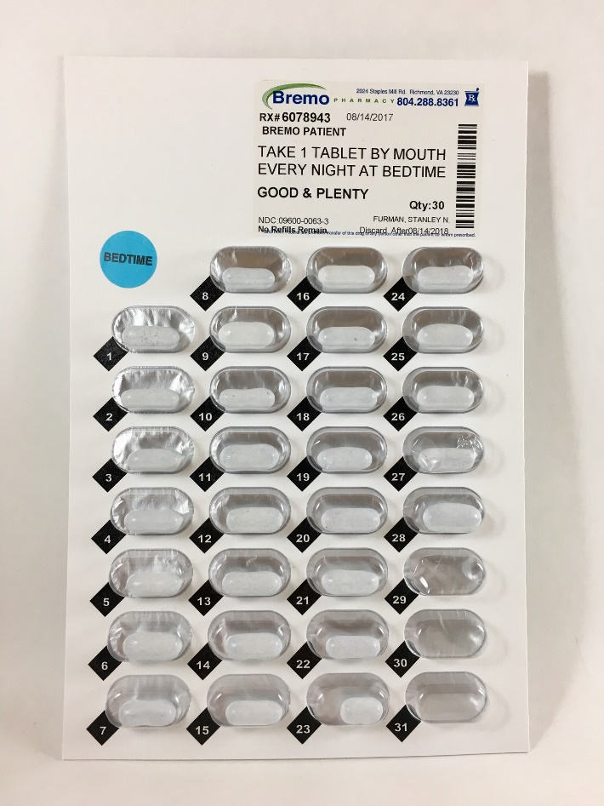

Pharmacy Copy, please read and sign

Agreement to Participate in the
Synchronized Prescription Refill Service
Thank you for your interest in the SyncRx at Bremo Pharmacy. Advantages
of participating in the program include:
- Increased convenience—a single monthly trip to the pharmacy or delivery
- Peace of mind from being able to get medications on time and in one order
- More personal contact with your pharmacist to ask questions and discuss medications
- Increased understanding of your medication, its purpose, potential side effects and costs.
- Your prescription records can be more easily updated to reflect changes in therapy made by doctors or upon hospital discharge.
- Monthly Pocket Medication lists
- Benefits offered: waived packing fees, waived delivery fees, waived medication disposal
I understand the program advantages and the following conditions of participation to achieve the maximum benefits from the service. I hereby agree:
- To accept a monthly phone call from Bremo pharmacy to discuss my chronic prescription refills.
- To pick up medications or accept a delivery on my assigned refill date.
- To keep an open dialogue with my pharmacist regarding doctor’s appointments, hospital/urgent care visits, and changes in my health status, or address.
- To inform the pharmacy of any changes in contact information or address.
- If necessary, to pay an extra co­pay one time for each medication in order to make all refills due on the same day.
I have read this document, understand it, and have had all questions answered satisfactorily.
- Patient request Dispill (multidrug) 30 day packaging OR
- Patient requests Bubble packing 30 day individually per drug OR
- Bottles
- Home Delivery
- MAR; HOA= ____________________________________________
- Other special needs: ______________________________________

_______________________________________________________________
Patient Name (Please print)
________________________________________ _______________________
Patient Signature Date
________________________________________ _______________________
Pharmacist Signature Date

30
New Patient Information Form  Name _________________ ___ _________________ |  | Date of Birth ____ /____ /____  mm dd yy
First MI Last Name
SSN ____________________________ |  |  | ❏Male ❏Female
Address __________________________________ __________________ __ ___________
Street City State Zip Code
Phone ______ - ______ - _________ ❏ This is my preferred form of contact
E-Mail ____________________________ ❏ This is my preferred form of contact
Family Contact: _______________________ Relation :_____________________
Phone : _____-_____-_____ ❏ I give my consent to contact regarding my prescriptions/payments
Primary Care Physician _________________________________________________
- ***** Drug Allergies❏ no ❏ yes, describe reaction: _____________________________
- How did you hear about our program:_________________________________________
Primary Prescription Insurance Information
Plan Name: _______________________________ RX BIN:____________ RX PCN:_____________
ID #: _____________________________________ RX GROUP: _______________
Secondary Prescription Insurance Information
Plan Name: _______________________________ RX BIN:____________ RX PCN:_____________
ID #: _____________________________________ RX GROUP: _______________
Pharmacy Help-Desk Phone #: ___________________________
Preferred Method of Payment: ❏Cash on Delivery ❏ Credit Card ❏ Check
Please check the following health conditions you have
❏ Acid Reflux (GERD)  ❏ Anxiety  ❏ Arthritis  ❏ Asthma  ❏ Bipolar disorder  ❏ Cancer  ❏ Chest pain (Angina)  ❏ COPD  ❏ Congestive heart failure  ❏ Depression  ❏ Diabetes (Type I or II) | ❏ Kidney disease  ❏ Emphysema  ❏ Glaucoma  ❏ Hardening of arteries  ❏ Headaches  ❏ Hypothyroid  ❏ Hyperthyroid  ❏ Irregular heart beat (Arrhythmia)  ❏ HIV / AIDS  ❏ High blood pressure  ❏ High cholesterol |  |  | ❏ Liver disease  ❏ Parkinson’s disease  ❏ Previous heart attack  ❏ Previous stroke  ❏ Schizophrenia  ❏ Seizures  ❏ Sexual dysfunction  ❏ Skin problems  ❏ Stomach ulcers  ❏ Thyroid Problems  ❏ Other _______________
Do you currently smoke? ❏Yes ❏No If yes, how many packs per day? _________
Do you prefer NON-SAFETY CAPS for your prescription bottles? ❏Yes ❏No
I understand the importance& agree to notify the pharmacy if any of the above information changes ❏Yes ❏No
Signat Signature: __________________________________________________Date: _________________

Please list the medications you are currently taking:
Pharmacy Name: __________________Phone #_________________  Physician and phone #______________________________________  Rx # Medication name Strength/ Directions | Today’s Date:  ____________  List quantity remaining | Time(s) of day meds taken  AM, NOON, PM, Bedtime
RX #
RX #
RX #
RX #
RX #
RX #
RX #
RX #
RX #
RX #

